Homework 3

University of Central Florida

Department of Electrical and Computer Engineering

Digital Communications (EEL4515C), Spring 2024

Issued: Mon, Feb 19 Due: Wed, Feb 28.

1. Solve Problems 5.1-1, 5.1-5, 5.2-1, 5.2-3 in the book (5th edition)

Sampling Frequency (Min) = 420 Hz

(b) $g\left(t\right)=5{sinc}^{2}{(6500πt)}$

$$G\left(f\right)=\frac{5}{13000}Δ\left(\frac{f}{13000}\right)$$

Sampling Frequency (Min) = 13 kHz

(c) $g\left(t\right)=\operatorname{sinc}\left(1800πt\right)+{sinc}^{2}{(2000πt)}$

$$G\left(f\right)=\frac{1}{1800}Π\left(\frac{f}{1800}\right)+\frac{1}{4000}Δ\left(\frac{f}{4000}\right)$$

Sampling Frequency (Min) = 4 kHz

(d) Sampling Frequency (Min) = 800 Hz

For part d, I had to perform convolution (graphically) for both signals in frequency domain, since both signals are rectangular functions, the convolved function will fall linearly as less the area shared decreases with a higher value.

2. 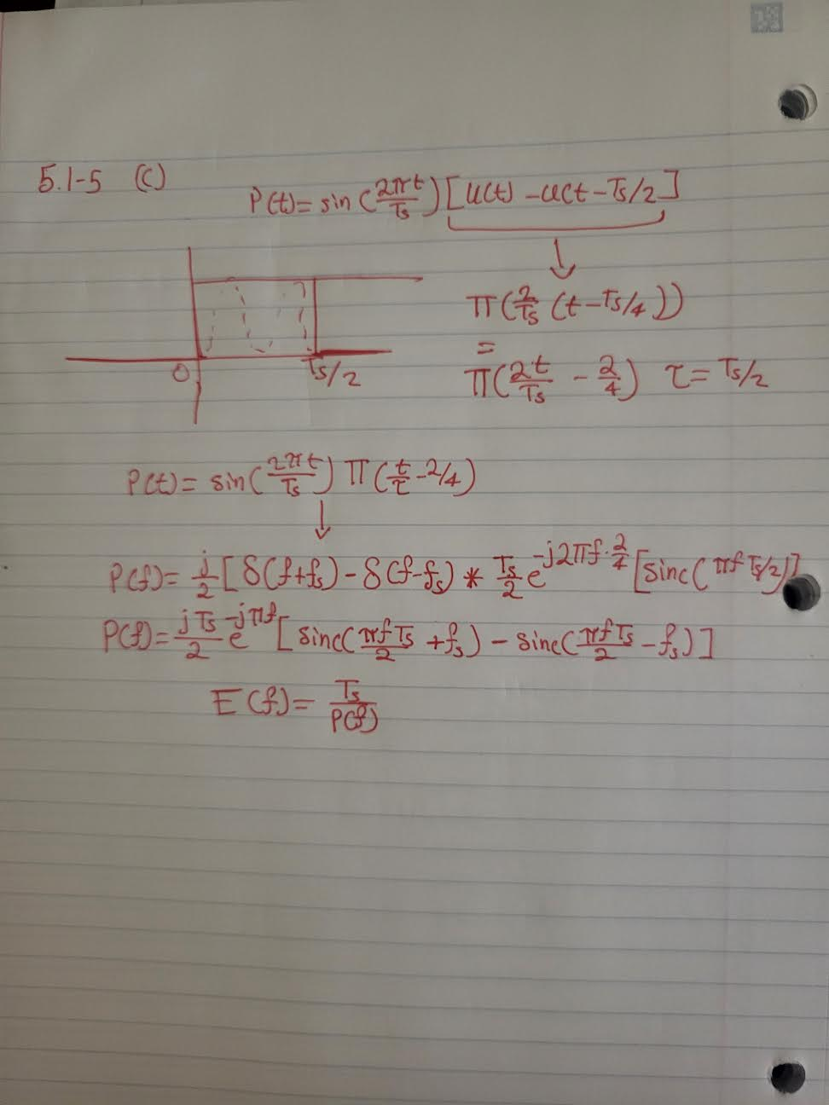

1. bits
2. SQNR = $\frac{3S_{o}L^{2}}{m_{p}^{2}}$ = $\frac{3*0.1*(2^{32}+1)}{1^{2}}≈1.28*{10}^{9}$
3. We must sample at least twice the highest frequency to meet Nyquist,

1. -- -- , bits
2. Nyquist: 30 kHz – Sampling Rate: 32.4 kHz per stero channel  
   Total Samples (Left and Right channels): 32.4 kHz \* 2 = 64.8 kHz
3. 64.8 kHz \* 7 bits = 453.6 kbps or 56.7 kilobytes per second for each channel  
   Total bit rate for all channels: 453.6 kbps \* 500 channels = 226.8 mbps

1.02\*226.8 = 231.336 mbps bit rate with 2% more bits

BW(min) = 231.336/2 = 115.668 mbps